on-line TUTORIAL
The MODI and VAM Methods
of Solving Transportation Problems

Discussion Questions
1. Vogel’s approximation method gives a good initial solution because it makes each allocation on the basis of the opportunity cost, or penalty, that would be incurred if that allocation is not chosen. The northwest corner rule does not take into account the shipping costs associated with each route alternative as does VAM. Nevertheless, the northwest corner rule could provide as low-cost an initial solution—but only if, by chance, it turned out that the lowest cost routes happened to be on the initially assigned squares.
2. The major difference between the MODI and stepping-stone methods is in the procedure used to test for optimality. In the stepping-stone method, we first draw a closed path for each of the empty squares to calculate its improvement index. Then, the most favorable square (i.e., the one with the largest negative index) is identified. In MODI, however, we first identify the most favorable square (by using row and column numbers) and then draw a closed path (only for that path) to direct us in improving the
solution.
End-of-Tutorial Problems
T4.1 (a) Hardrock’s initial solution using the VAM method is
shown below:
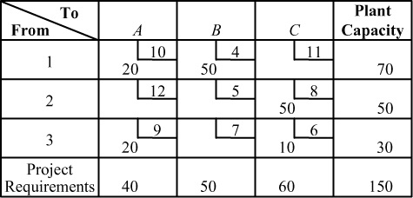

Cost = 20($10) + 50($4) + 50($8) + 20($9) + 10($6) = $1,040
(b, c) Since this solution is optimal, total cost remains unchanged, at $1,040.

T4.2 Hardrock’s problem now requires the addition of a dummy project (destination) because supply exceeds demand. The VAM initial solution is as follows:
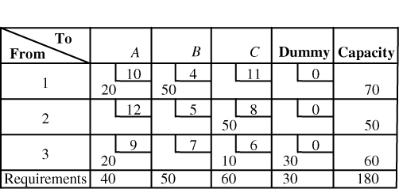
Cost of initial solution = 20($10) + 50($4) + 50($8)
+ 20($9) + 10($6) + 30($0)
= $1,040
This is the same initial assignment and cost as that found in Problem T4.1.
The optimal solution, whose total cost is also $980, is shown in the following table. An alternate optimal solution also exists:
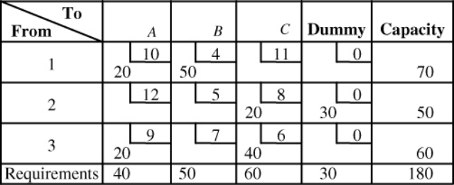
T4.3 (a) Using the northwest corner rule for the Saussy Lumber
Company data, the following initial solution is reached:
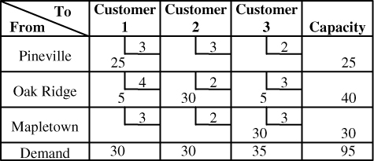
Initial cost = 25($3) + 5($4) + 30($2) + 5($3) + 30($3) = $260
(b) Solving the Saussy Lumber Company problem with MODI, we begin with the same initial solution as found in part
(a) above:
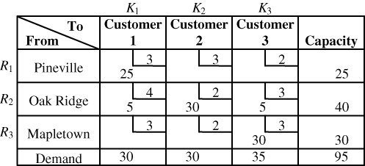

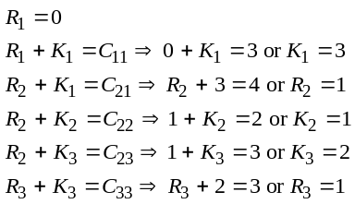
Improvement indices are as follows:

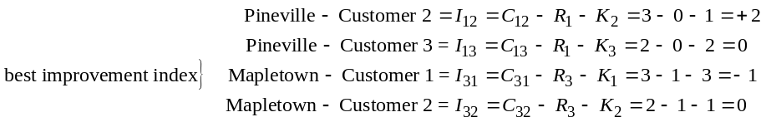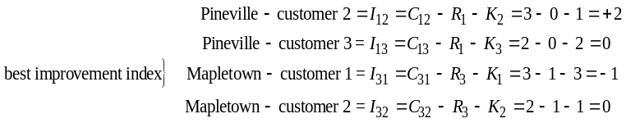

The final solution is also evaluated using MODI below.
Calculations of the Ri’s, Kj’s and improvement indices are:
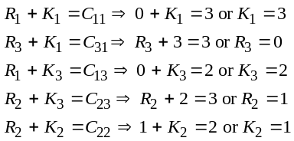
Improvement indices:
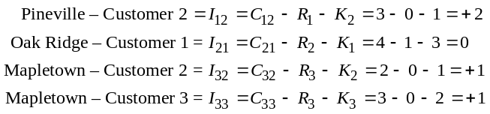
Final solution with Ri and Kj values:
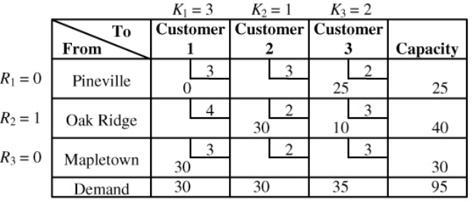

T4.4 Krampf Lines Railway Company’s initial northwest corner solution is shown below:
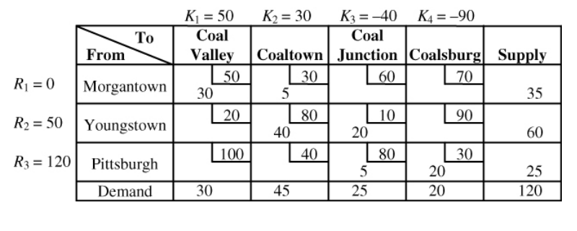
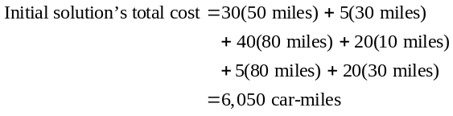
To test for improvement with MODI, we set up an equation for each occupied square:
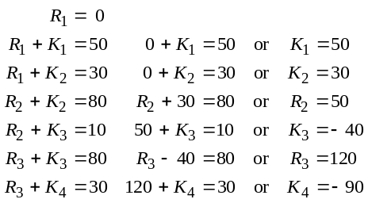
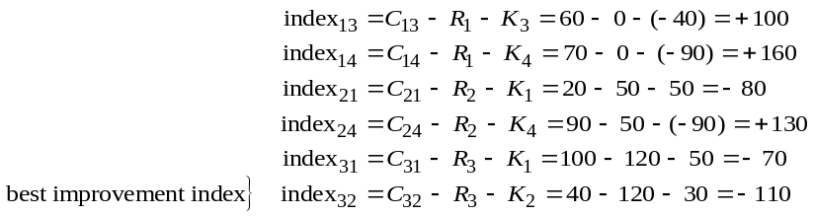
Second Krampf solution—cost = 5,500 miles:
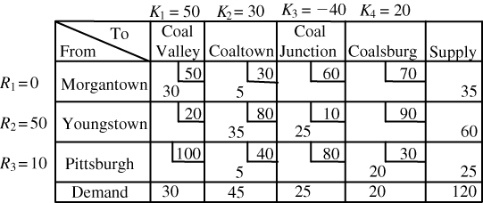
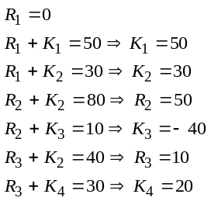

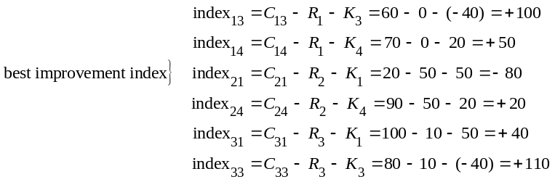
Third and optimal Krampf solution = 3,100 miles:
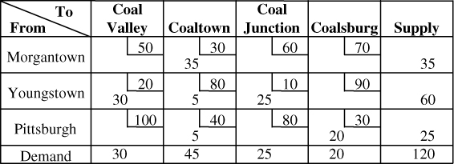
T4.5 Jessie Cohen Clothing Group’s first VAM assignment table:
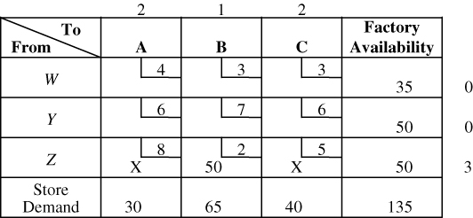
In the initial assignment table above, we see that the Z row has the greatest difference (3). We assign the minimum possible number of units (50) to the least-cost route (Z − B) in that row.
Second VAM assignment with B’s requirement satisfied:
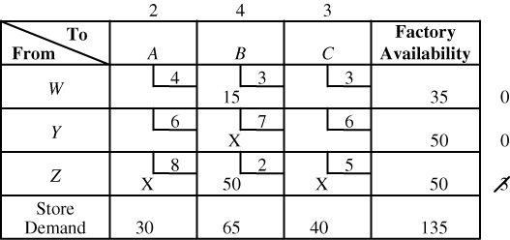
This second VAM table (above) indicates that the greatest difference is now in the B column (4). We may assign up to 15 units to the W − B square without exceeding the demand at store B.

Third VAM assignment with W’s requirement satisfied:
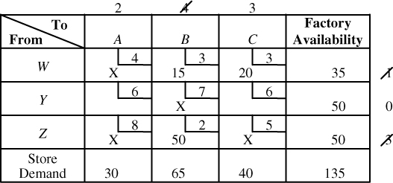
The third VAM table involves assigning 20 units to the W − C route. This is done because column C has the highest difference and square W − C the lowest cost in that column.
Final assignment for Cohen Clothing Group:
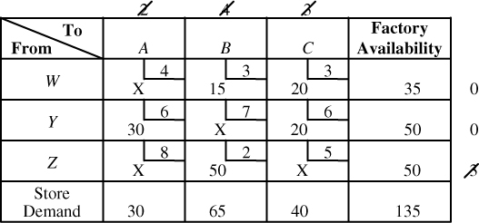
The final assignment (above) is made by completing the row and column requirements. This means that 30 units must be assigned to
Y − A and 20 units to Y − C.
The total cost of this VAM assignment:
= (15 units × $3) + (20 units × $3) + (30 units × $6)
+ (20 units × $6) + (50 units × $2) = $505.
A quick check using the stepping-stone index method indicates that this VAM solution is also optimal.
T4.6 (a) VAM steps are as follows:
- Assign 30 units to C − W (the W column has the greatest difference, 7) and place X’s in all other row C squares.
- Assign 20 units to B − X.
- Assign 10 units to B − W.
- Assign 20 units to A − Z.
- Assign 35 units to A − Y and 15 units to B − Y.
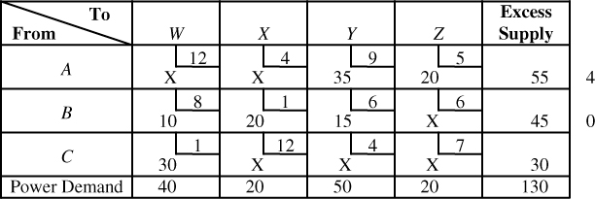
Total VAM cost = 35(9) + 20(5) + 10(8) + 20(1)
+ 15(6) + 30(1) = 635

(b) MODI technique to test for optimality:
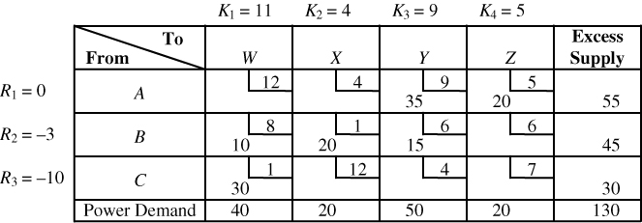
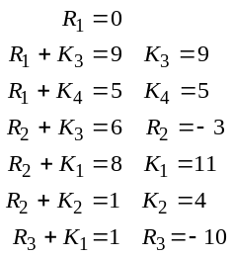
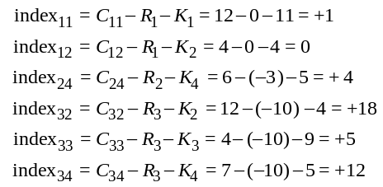
Because all improvement indices are zero or positive, this solution is optimal. An alternative optimal solution, however, is A − X = 20, A − Y = 15, A − Z = 20, B − W = 10, B − Y = 35, C − W = 30, cost = $635.

